**Viva Glenn Piper**

It's 5:45 pm at the Richmond Street running track in Ashton-Under-Lyne when a car pulls up and out steps East Cheshire Harriers and Tameside AC coach Glenn Piper. He takes his bag out of the car and then heads over to unlock the gates to the track and heads to the Marley building to turn on the flood lights. It's time to put the local athletes through their paces for the next hour.

Over the next 15 minutes you start to see the slow jogging of those arriving for Glenn's session, grouping together completing their warmups on the track and around the outside on the grass. Congregating together just after 6pm listening for instruction on what the plan is for the session, it's then time to run through some warmup drills and then to the trained ear of all in attendance the sound of Glenn's favoured whistle rings out to signal the start of the harder stuff.

Glenn has been conducting sessions as a coach for the club for 3 years and has navigated the tough times coming out of the Covid lockdowns, maintaining small group sizes and following social distancing to adhere to government guidance. Thankfully this is no longer something to consider, and the group has grown in numbers and with-it positive development and progress of everyone involved in the sessions.

**What does coming to the session involve?**

There are 2 weekly sessions for Glenn's group, meeting at the East Cheshire club house held on Tuesday and Thursday from 6pm for an hour. During the Winter months the training will be usually on the grass around the outside of the running track where Glenn will have a plan of what interval training we will be doing. The group has also been fortunate to be able to use the Tameside cycle track once a month and hold a speed session on there and more recently also started to use Astley Road at the side of Stamford Park for hill sprints.

In the lighter, brighter summer months the meeting point is still the same but once a week they head over to Daisy Nook Country Park to hold a session there.

Glenn's sessions are designed to strengthen you as an athlete and build your endurance and ultimately make you quicker. This involves a mixture of running with 80-100% effort and recovery running.

Glenn's group has grown in numbers in the last 12 months with new to running members, those new to a running club, those transferring from other running clubs and returning athletes.

All abilities are welcome with Glenn keeping the session the same for all but with adjusted start points for different ability groupings.

Outside of the club sessions Glenn is always encouraging the meet up of group members for the weekend long run and will regularly organise a park run meet up to attend. The idea that being in a competitive group and working together at the parkrun should see you push that bit harder and be looking to improve your overall age graded score, which in turn should push you up the 'ECH Parkrun Age Graded Yearly Championship'.

**Successes this year**

For the East Cheshire brand, the success is signing up more members and getting more people involved at events representing and growing the club. Fielding more athletes and teams at events and also stronger teams. The growth itself is making the club more attractive to anyone considering joining a club and making ECH one club that's hard to turn down.

This year within the group there has been race wins, great team placings, improvements on individual placings, England vest success, representation at different events for the first time for some and of course numerous massive PB's at all distances across the group.

There are far too many to list from the group this year but here are a few stand out PB's from where they were to what they are now:

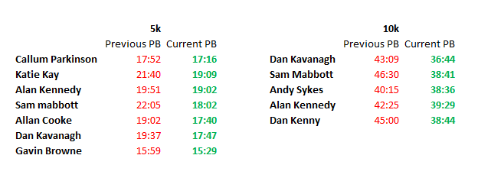

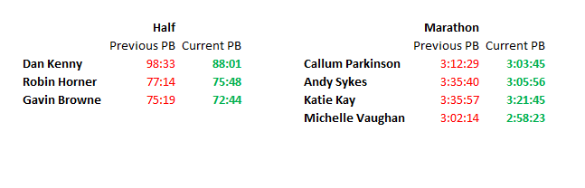

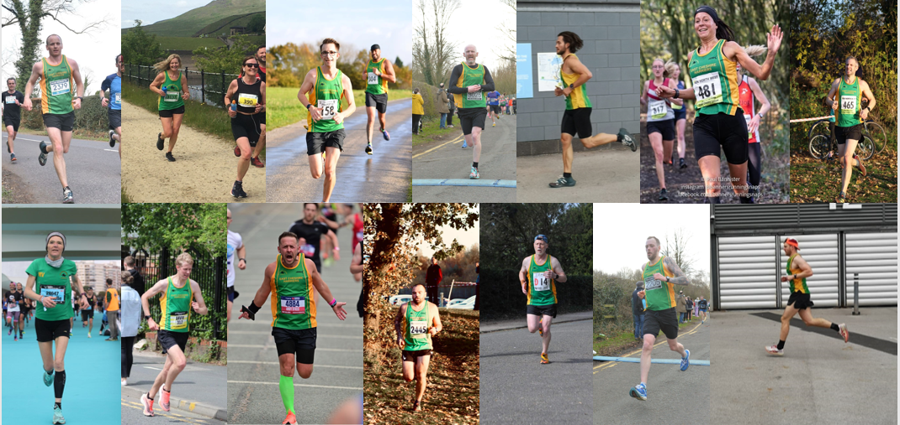

I asked some members of the group a few questions to get an idea of what it's like training with Glenn's group. here's what they had to say.

Dan Kenny

**As someone who has joined the club this year, what would you say about the training on offer, the people at the sessions and how has it helped you since joining?**

After training for the MCR half in May on my own at the start of this year and coming home 7 minutes faster than I wanted to this is when I knew I wanted to step up my running. Knowing Glenn already from family holidays as a kid I knew coming down to ECH would be a good fit.

The training on offer is great from endurance to speed and hill reps which is something I'd never done before. I would normally just go for a run at a fast pace which I now know is no go. You have to run slow to run fast! The different types of session have been a big help and I've learnt lots.

The people at the sessions are class, some may say the perfect group to train with. There's a range of abilities across the group who always encourage each other. The Sunday Long Runs in groups formed from the training group or running with a partner such at Jake has also helped. It's a case of forget about the run, the pace, the distance and just have a chat, then before you know it the 11-14 miles are done.

Joining ECH has been massive for me not only helping with running motivation but the mental side of the sport too. I've managed to go from; 22.30 5ks to 18.24, 45 min 10ks to 38.44 and I've taken 10 mins off my half time from earlier in the year with a new PB of 88 mins. All these are things I never thought I would be able to achieve. Next year I'm doing MCR Marathon and can only reiterate the point that if I had not joined ECH… I wouldn't be doing it!

Hayley Simpson

**As someone who has been a lifelong East Cheshire Harrier, what is it like to see so many more seniors joining up to Glenn's sessions and subsequently representing ECH at events?**

It’s amazing to see the increase of senior members over the last year. I remember when I was young at the club the senior end of the club was thriving. As juniors we had so many role models to look up to.

It’s now starting to look that way again. Our juniors now have a huge number of role models.

In addition, it’s brilliant that Glenn is getting such high numbers. All the unpaid hours as a volunteer coach that Glenn puts in must be made worthwhile when you see so many green and gold vests on the start line of events.

There are so many volunteers who work tirelessly to keep our club going. To have the ‘East Chesh’ name represented highly in events is a way of saying thanks to all those volunteers.

I hope this is just the start for our senior team and that it grows and grows on road, XC, the fells and track & field!

#GoOnEastChesh

Katie Kay

**As someone who transferred to Eash Cheshire Harriers from another running club this year, can you tell me firstly what made you consider the move and was there a deciding factor? Also, how has it been since joining?**

As everyone knows, I always referred to myself as ‘Katie one speed’ or ‘Katie the plodder’ - it didn’t matter if I was running 2 miles, or 20 miles, they would always be at the same speed! I don’t race very often; I have always enjoyed running just for the social and to generally keep fit (and so I can eat cake! 😆). But when I did ever attend a race or speak to other local runners, they would always tell me that I should try mixing things up a bit and do some speed work as I might just be surprised!

When I joined the team at the local runners podcast last year, chatting to the guys (Dave, Callum & Sean) as well as listening to guests, I started to become more intrigued and interested in what people were saying about ‘sessions’ - at this point I had no idea what a session was - a run was a run to me!

I was still a member of Hyde Village Striders but started to attend Glenn’s sessions (a mixture of speed and hills) once a week and really enjoyed them, and I started to see gradual improvements in my running. Glenn continued to offer support to me outside of these sessions and my running improved significantly; I started to realise I had another gear and could push myself out of my comfort zone to achieve greater things. I really enjoyed seeing these improvements and seemed to fit in well with the group at ECH. There was also the talk of team events, something which really appealed to me but again something I hadn’t really had the chance to get involved with before. So, I made the plunge to move clubs and really haven’t looked back.

I will never forget my time at Hyde Village Striders and am grateful for the impact they had in getting me running and building my confidence, but I think the time to move clubs and to experience something new in my training was just what I needed. In the few months I’ve been working with Glenn, I’ve seen massive improvements. He’s taught me that I don’t have to be 'Katie one speed' and that I do have another gear. Pushing myself outside of my comfort zone in the training sessions has made my running come on leaps and bounds. Never did I ever believe that I would run a sub 3:30 marathon, but then absolutely smash that time and achieve 3:21! Nor did I believe I could ever achieve a sub 20 minute 5k, but I’ve recently broke that…. and more than once!

I would say the input of a hands on, supportive and encouraging coach has been invaluable to me. I’m very grateful for Glenn taking me under his wing and helping me to better understand what I’m capable of and gently pushing and encouraging me. I’m loving being part of a ladies team too and engaging in team events, again something which is all new to me. I’m very excited and looking forward to what I can continue to achieve. Joining ECH under the guidance of Glenn was definitely the right move for me ☺️

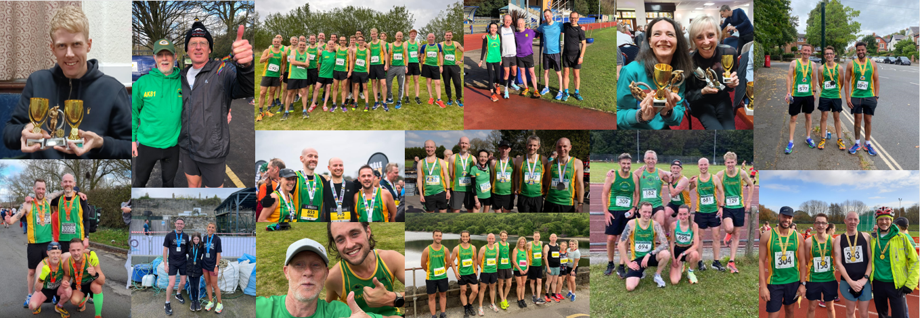

**Dan Kavanagh**

**As someone who has been pushing and making improvements all year, can you tell me what your standout performance is and why?**

On reflection I'd say the Knutsford 10k. It was a PB at the time, 36:58. It was my first time under 37 and only my 2nd time under 38 mins for a 10k. I felt like this run was one of the first where I actually had a plan, and a pace I had to hit for each KM. Originally this was for 37:30, however, I felt great on the morning of the race and the pace I was running at felt comfortable so when it came to the last couple of KMs I knew I had some left in the tank...the last 400m was a flat out sprint as I knew I'd be close to sub 37, at one point I literally swore at myself (out loud haha) to run faster. The feeling at the end was incredible and I probably won't forget it in a hurry. It stands out for me as, at the start of this year, I never thought I'd be where I am now, and it's given me the confidence to push even more and keep improving. Which I then did by bettering that time a few weeks later at the Wilmslow festive 10k.

**Gavin Brown**

**A lot of the newer joiners to Glenn's group came and openly said it was off the back of hearing you and Liam appearing on the Local Runners Podcast. How does that make you feel knowing that you've been able to draw new members to sign up?**

Wow, we weren't aware of that. Did people get us mixed up with the Brownlee Brothers!? Joking aside, it's overwhelming to hear this and it's been great to see so many new members joining the club recently. We just wanted to get across what a great local community club East Cheshire Harriers is, and it's been a pleasure to be a member for over 20 years. It's been brilliant to see so many of the new members competing for the club including putting record number of teams out in relay events this year. It's also seen an improved social side to the club, one thing we mentioned on the podcast we needed more of. Long may it continue!

**You've won a few of the local races throughout the year, looking on power of 10 this is a step forward in placings for you, what would you put that down to?**

I've had a really successful year and seen massive improvements by running PB's in all distances and winning some local races which I'm extremely proud of. A lot of thanks go to coach Glenn Piper for his knowledge, advice and guidance which has allowed me to train consistently and keep injury free this year. He has fresh new ideas and his variety of sessions on different terrains and in different locations has kept things interesting and are well thought out. This has seen a large number of runners attend his sessions which has subsequently made me train harder trying to hold other runners off! Here's to 2023!

**Michelle Vaughan**

**As a senior who has been coached by Glenn, you've achieved some amazing results this year, your Half Marathon is the current 8th fastest of the year in your V50 category and your recent Marathon in Valencia is 9th for the year. What impact has working with Glenn had on you and your training and then ultimately your results?**

I think the first thing to say is Glenn took an interest in me when nobody at the club was particularly interested in somebody who liked running on the roads and in particular, flat roads. I have done Cross Country and represented ECH on the track but for me what Glenn offered was someone who was interested in me and trying to help me move forward and he did this during Covid. He helped by keeping me engaged, I was able to compete in races during the Covid years and it was great to have that level of interest and support. I think what's really key about Glenn is the co-production, he listens to what you say you think works for you and will tweak things based on what you feel. The other thing is that he believed in me and really made me genuinely believe that the sub-3-hour marathon was possible. This was important as I didn’t necessarily believe in myself. He's also been really good as a sounding board if something has not quite worked for me in training, I would just run it by him and I think what he's done has sort of inspired East Cheshire itself to have greater road running ambitions and that’s spread through to the athletes as well to have positivity about and consider the road as well.

Talking about my results, Glenn set a good platform for this to be achieved and I know Frankfurt didn't go to plan, but I managed to achieve the result I wanted in Valencia, and I feel that Glenn was instrumental in setting me at that platform. Glenn also didn't try to discourage me increasing my training load as I do feel that there are other coaches out there who was say 'You're in your 50's now so you need to decrease and you need to do more cross training', Glenn didn’t do this, he trusted my judgement and now I'm up to double running 4 or 5 times a week and I think this is what stands him out as he listens to what you want and what you think is best for you.

**So…. Viva Glenn Piper**

For me, Andy Sykes, I echo everything that’s been said. I think as a group we've grown in numbers but in ability too and the results that our athletes are getting are an incredible thing to see. The friendship on offer within the group is amazing and I've seen my own gains this year too. When I was running the Manchester marathon this year in April and heading back up towards Old Trafford, Glenn and some of my club mates were at the side of the road though mile 23. I'll never forget that my pace was starting to slow a bit and aside from the encouragement from everyone, Glenn ran at the side of me telling me to breathe easy, where I was in distance on the course and that I was already doing a brilliant job and on course for my target. Priceless support from everyone and great words to reassure me in one of the harder moments.

Do you want to get involved? Does East Cheshire Harriers tick your boxes? If so then reach out on the email address below to find out more:

Eastchesh@gmail.com

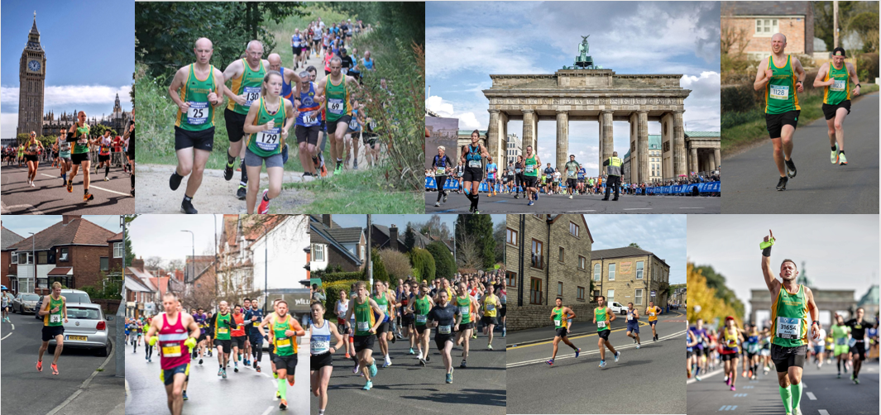

Photo credits

Mick Hall

Jon-Paul Kearns

Banners Running Snaps

Marathon Photo

AWOL photos